SpendWise
INTRODUCTION
Project Title : Spendwise
Team ID : SWTID-2026-6869
TREM LEADER : GOKILAVANI S (gopigoki2922@gmail.com)
ROLE : CODING AND DEVALOPMENT
TEAM MEMBER : BAIRAVI R (r.divya1320@gmail.com)
ROLE : CODING AND DEVALOPMENT
TEAM MEMBER : MEKALA B (iammekala123@gmail.com)
ROLE : DEMO VIDEO
TEAM MEMBER : DHARSHINI S (dharshinisakthivel030607@gmail.com)
ROLE : DOCUMENT CREATER

- Project Overview
SpendWise is a backend application designed to help beginner developers learn how to build secure REST APIs using Node.js, Express, MongoDB, and JWT authentication. The project focuses on implementing user authentication and basic CRUD operations in a clean and simple way so students can understand how backend systems w
Key Objectives:
- Provide secure user authentication using JWT
- Enable basic CRUD operations on user data (transactions/records)
- Demonstrate MongoDB integration using Mongoose
- Show how protected routes work using middleware
- Maintain a simple and beginner-friendly backend architecture
ork in real-world scenarios.
- Target Users:
- Beginner backend developers
- Students learning Node.js and Express
- Freshers preparing for technical interviews
- Anyone who wants a simple project to understand JWT and MongoDB
- Learners who want hands-on practice with REST APIs

Project Instruction
SpendWise is a backend-only project built using Node.js and Express.
- Quick Start:
npm init
npm install
npm run dev

- Steps to Create the Project:
- Choose or create a directory for the backend project.
- Open terminal and navigate to that directory.
- Initialize Node.js project using npm init.
- Install required packages: express, mongoose, jsonwebtoken, bcrypt, cors, dotenv.
- Create folders: models, routes, controllers, middleware, config .
- Start the server using npm run dev.
Test APIs using Postman or Thunder Client at http://localhost:5000.

Pre-requisites:

- Software Requirements

Software | Purpose
Node.js | JavaScript runtime for backend
MongoDB | NoSQL database for data storage
npm | Package manager
Git | Version control system
Code Editor | VS Code or similar

- Knowledge Requirements

- JavaScript ES6+
- Node.js and Express.js
- MongoDB and Mongoose
- JWT authentication
- Basic REST API concepts
- Git basics

Project Architecture Image

Technical Architecture

- Backend Architecture (Node.js + Express)

- Controllers: Handle business logic for authentication and CRUD
- Models: Mongoose schemas for User and Transaction
- Routes: API endpoints for auth and CRUD operations
- Middleware: JWT verification and request protection
- Configuration: Database connection and environment variables

- Database Architecture (MongoDB)

- Users Collection:
_id, name, email, password (hashed), createdAt
- Transactions Collection:
_id, userId (FK), title/description, amount/value, createdAt
- Relationship:
Many Transactions belong to One User

ER Diagram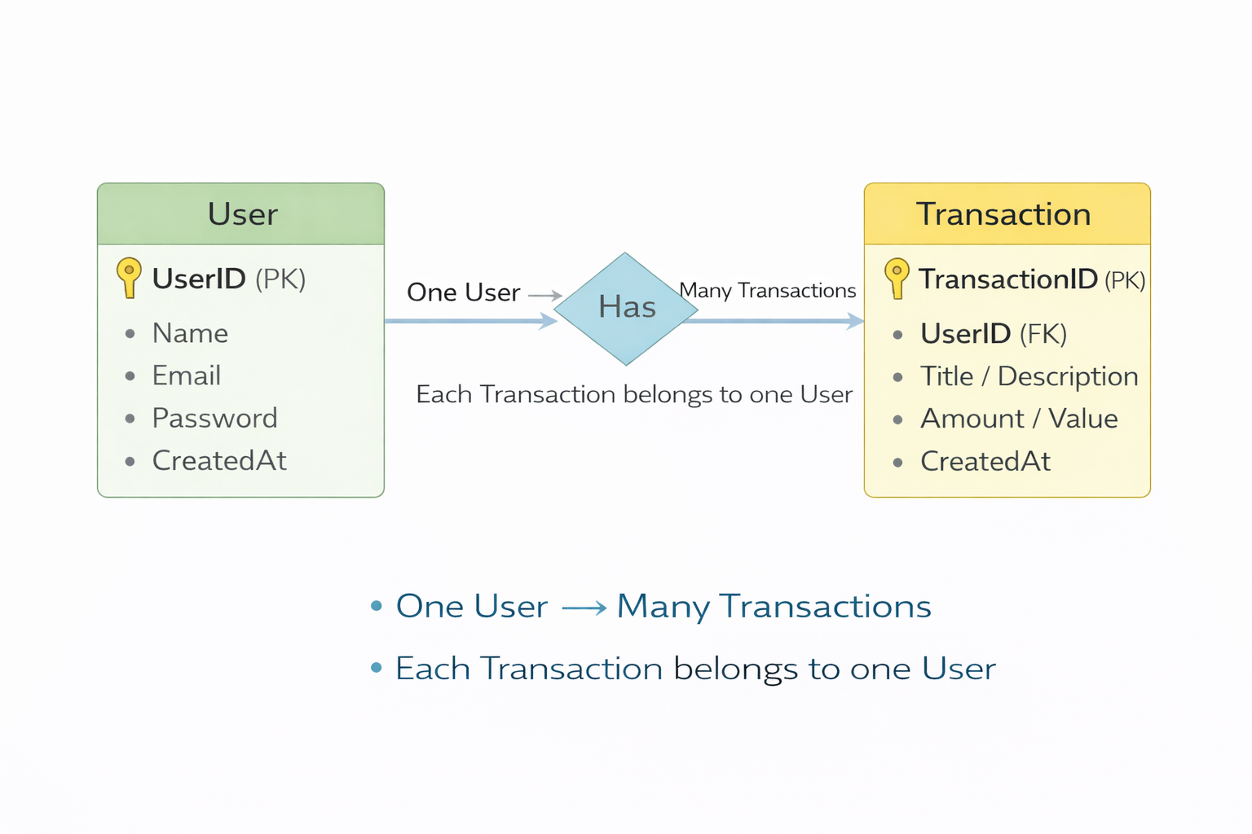S

Features

Feature

Description

User Authentication

JWT-based registration and login

CRUD Operations

Create, Read, Update, Delete transactions

Protected Routes

Secure APIs using JWT middleware

MongoDB Integration

Store and fetch data using Mongoose

Roles and Responsibilities

Student / Developer:
- Write backend code
- Create APIs
- Test APIs using Postman/Thunder Client
- Push code to GitHub

- System (Backend):
- Authenticate users using JWT
- Handle CRUD operations
- Store and fetch data from MongoDB
- Protect private routes

PROJECT SETUP AND CONFIGURATION

Folder Structure
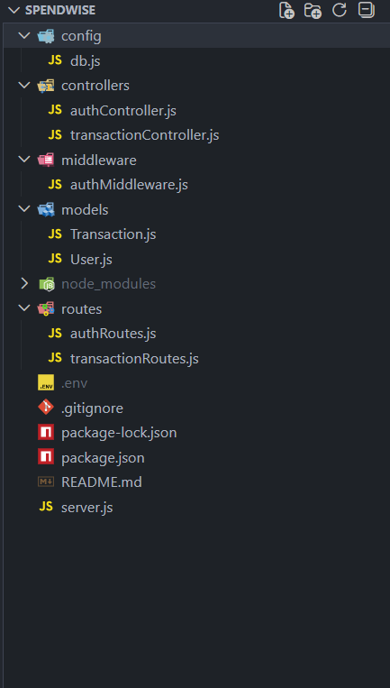

- Project Setup
1. Install required tools:
- Node.js
- MongoDB

2. Create project folders:

- server folders (models, routes, controllers, middleware, config)

3. Install Backend Packages:

- Express
- Mongoose
- Cors
- Jsonwebtoken
- Bcrypt
- Dotenv

